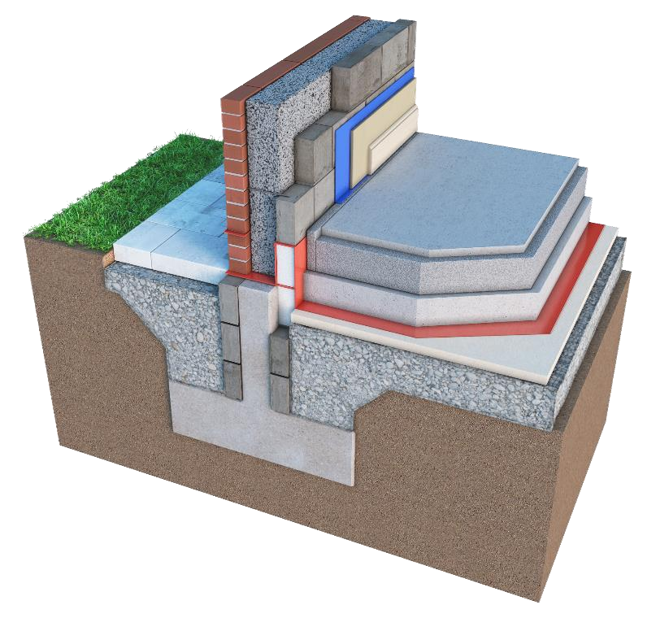
KOREFILL Cavity Wall Insulation
System

NSAI Agrément (Irish Agrément Board)

is designated by Government to carry out European Technical Assessments.

NSAI Ag
rément Certificates establish proof that the certified products are
‘proper materials’

suitable for their intended
use under Irish site conditions, and in accordance with the
Building Regulations 1997 to 2019
.

IRISH AGRÉMENT BOARD

CERTIFICATE NO. 07/0293

KORE Insulation.

Kilnaleck, Co. Cavan.

Tel: +353 494336998

Fax: + 353 494336823

Email:

info@koresystem.com

Website:
e
www.kor
-
system.co
m

PRODUCT DESCRIPTION  This Certificate relates to the KOREFILL Cavity Wall Insulation System.  KOREFILL Cavity Wall Insulation is an expanded polystyrene material which is injected in bead form with a binding agent into masonry cavity walls.  In the opinion of NSAI, the KOREFILL Cavity Wall Insulation System, as described in this Certificate, complies with the requirements of the Building Regulations 1997 to 2019.  USE  The product is used for the thermal insulation of new or existing cavity walls up to 12 meters in height, where both leaves are constructed of either masonry or concrete or a combination thereof, subject to the conditions contained in Part 3 of this Certificate. It also facilitates the control of surface and interstitial condensation in walls. | The product is approved for both full fill or partial fill situations when a residual cavity width of 40mm or greater exists subject to the conditions identified in Cl. 2.4.4 of this certificate.  MANUFACTURE AND MARKETING  The product is manufactured and marketed by:  KORE Insulation,  Kilnaleck, Co. Cavan.  Eircode A82T291  Tel: 049 4336998  Fax: 049 4336823  Email: info@koresystem.com  Website: www.kore-system.com

Readers are advised to check that this Certificate has not been withdrawn or superseded by a later issue by contacting NSAI Agrément, NSAI, Santry, Dublin 9 or online at www.nsai.ie

1.1 ASSESSMENT
In the opinion of NSAI Agrément, KOREFILL Cavity Wall Insulation if used in accordance with this certificate, can meet or contribute to meeting the requirements of the Irish Building Regulations 1997 to 2019 as indicated in Clause 1.2 of this Agrément Certificate.

1.2 BUILDING REGULATIONS 1997 to 2019

REQUIREMENT:

Part B – Fire Safety B3 & B8 – Internal fire spread (Structure)
When used in accordance with this certificate, the KOREFILL Cavity Wall Insulation System can meet the relevant requirements of TGD Part B3 and B8.

Part C – Site Preparation and Resistance to Moisture C4 – Resistance to Weather and Ground Moisture
The KOREFILL Cavity Wall Insulation System can meet the relevant requirements of TGD Part C4, when installed in accordance with this Certificate.

Part D - Materials and Workmanship
D1 KOREFILL Cavity Wall Insulation used in accordance with this NSAI Agrément Certificate can meet the requirements of TGD Part D1.

D3 – KOREFILL Cavity Wall Insulation, as certified in this NSAI/Agrément Certificate, is manufactured from materials which are 'proper materials’ fit for their intended use (see Part 4 of this Certificate).

Part F – Ventilation F1 – Means of ventilation
The systems as certified can be incorporated into structures that will meet the requirements of this Regulation. See Clause 2.4.2 (Site Preparation) of this Certificate.

Part J – Heat Producing Appliances J3 – Protection of Building
In the opinion of NSAI Agrément, KOREFILL Cavity
Wall Insulation if used in accordance with this
Certificate can meet the requirements of TGD to Part J of the Building Regulations 1997 to 2019.

Part L – Conservation of Fuel and Energy
L1 – Conservation of Fuel and Energy Walls using KOREFILL Cavity Wall Insulation systems can meet or contribute to meeting the current U-value requirements in Full Fill Cavity Wall Insulation applications depending on the cavity width (see Table 1 and Clause 4.4 of this Certificate).

Certificate No. 07/0293 / KOREFILL Cavity Wall Insulation System

2.1 PRODUCT DESCRIPTION
KOREFILL Cavity Wall Insulation consists of an expanded polystyrene material injected in bead form with a bonding agent. The bonding agent is used to provide long-term stability to the insulant.

The polystyrene bead is delivered in a container and can be installed using a compressed air delivery system.

The Thermal conductivity (_{90/90}) of the KOREFILL Original Cavity Wall Insulation system has been measured at 0.035 W/(mK), for the Synthos 800FG/F or BASF F2300 beads and 0.033 W/(mK) for the KOREFILL Diamond, BASF F5200 bead.

These values are based on a target bead density on not less than of 12 kg/m³. Users should be aware when calculating U- Values, that the density of the bead together with the density of the installed product can vary and allowance should be made for these variations when calculating U Values. Installers should provide records of bead density used together with volume of bead used in each installation in order to more accurately determine actual U Values.

2.2 MANUFACTURE
The KOREFILL Original bead is expanded from Synthos 800FG/F or BASF F2300 bead with a manufactured minimum dry bead density of 11.5 kg/m³ (colour: silver/grey, shape: round). KOREFILL Diamond bead, is expanded from BASF F5200 bead with a manufactured minimum dry bead density of 11.5 kg/m³ (colour: dark grey, shape: oval).

The certificate holder offers two approved bonding agents, both manufactured and distributed by Dunwood Polymers:
- EMUPOL 6650, for use with the Synthos 800FG/F or BASF F2300 bead only.
- EMUPOL SAC 5700-07, for use with the Synthos 800FG/F, BASF F2300 or BASF P5200 beads.

2.3 DELIVERY, STORAGE AND MARKING
The KOREFILL Cavity Wall Insulation System is delivered to site in a bulk container. The relevant delivery paperwork is marked with the NSAI Agrément identification mark incorporating the number of this Certificate and a unique batch number. The bead material, which has an indefinite storage life, should be kept dry.

Both adhesives are delivered in their ready to use condition (no diluting or additives required) in a container which is labelled with the makers name, the product code, batch code, Shelf Life or Useby date together with the name KORE Insulation and incorporating the number of this Certificate.

They must not be allowed to freeze and should be handled in accordance with the data sheet as outlined in the Airpacks Ltd KOREFILL Installation Manual.

2.4 INSTALLATION PROCEDURE

2.4.1 Site Survey
A survey, as defined in Appendix A of the NSAI Agrément Assessment & Surveillance Scheme for Cavity Wall Insulation (CWI), is carried out prior to installation by a trained KOREFILL Cavity Wall Insulation surveyor. The surveyor must carry an identity card issued by KORE Insulation, certifying training and registration.

A complete survey report approving works (including a borescope survey) is prepared before installation and held at the Approved Installer's offices. Particular problems are specifically identified and any reasons for rejection of the work are noted.

Quotations, tenders and invoices shall bear the NSAI Agrément identification mark incorporating the number of this Certificate and the installer’s registration number.

2.4.2 Site Preparation
Before commencing work the installing operative ensures that the property has been correctly surveyed and is suitable for insulation with the KOREFILL Cavity Wall Insulation System. Any problems encountered during drilling which may prevent compliance with this Certificate are referred to the Certificate Holder before proceeding.

2.4.2.1 Ventilation
All ventilation openings such as that providing combustion air or under floor ventilation and all flues in the cavity wall are checked. If adequate sleeving or other cavity closures are not present, installation must not proceed until these openings have been sleeved or otherwise modified to prevent blockage by the insulant.

When installing the Cavity Wall Insulation System, the works to be undertaken must not compromise the existing ventilation provisions in the home.

When these existing ventilation provisions do not meet the requirements of Part F of the Building Regulations, the homeowner should be informed and remedial action should be taken before the cavity wall insulation system is installed.

When retrofitting dwellings for energy efficiency ventilation must be carried out in accordance with SR54^{[2]}.

2.4.2.2 Isolation form Electrical Cables The tops of cavity walls must be closed. Cavity filling should not be carried out unless electrical cables are placed in conduits or suitably isolated from the insulation material by cavity brushes or similar method approved by the Certificate Holder.

Due care shall be taken when drilling holes in the masonry wall to prevent contact with electrical cables.

2.4.3 Approved Installers
Installation of the KOREFILL Cavity Wall Insulation System shall be carried out by Airpacks Ltd. or by their Approved Installers who:

- Are registered with the NSAI Agrément CWI scheme.
- Are approved by KORE Insulation to install the product.
- Have undertaken to comply with the KORE Installation Procedure.
- All technicians and surveyors have been trained and issued with appropriate identity cards by KORE Insulation. All members of each installation team must carry a card verifying this training and registration.
- Are subject to supervision by KORE Insulation, including unannounced site inspections, in accordance with the NSAI Agrément
Assessment/Surveillance Scheme.

2.4.4 Procedure
The details in this certificate should not be considered a definitive set of installation instruction, but an overview of the procedures involved. Should a conflict arise between this certificate and the certificate holder’s manuals, this certificate takes precedence.

All requirements of the NSAI CWI Approval Scheme for Installers, including safety related issues, shall be met. The KOREFILL Cavity Wall Insulation System is installed using a compressed air system approved by KORE Insulation and notified to NSAI Agrément.

The installer provides all necessary ladders, restraints, scaffolding, hoses, drilling tools equipment and materials for making good the walls after the installation of the KOREFILL Cavity Wall Insulation System.

Prior to the commencement of the filling operation it is essential that the flow rates of the blown bead and adhesive are checked. This is carried out by filling a hessian bag with dry bead for 60 seconds, the bead is weighed and the weight recorded. Using the bead/flow chart supplied by KORE Insulation, the correct amount of adhesive is applied to the bead to ensure adequate bonding of the product in accordance with the KOREFILL Cavity Wall Insulation Systems Manuals.

Where an existing semi-detached or terraced property is to be insulated, the insulation is contained by inserting a cavity closer brush at the line dividing the properties. After filling, the nylon brush is retained in the cavity and the drill holes filled. The nylon brush can also be used to prevent the blocking of under floor vents with the blown bead where these have not been previously sleeved.

Care should be taken to ensure that drilled holes do not coincide with the intermediate suspended timber floor.

2.4.4.1 New and existing buildings without existing partial fill in cavity. Refer to Clause 3.2 of this certificate for the definition of new and existing building. All defects, such as missing ventilation sleeves or debris in the cavity, must be rectified prior to the installation of the bead.

Holes of 22 mm – 26 mm diameter are drilled in the outer or inner leaf normally spaced approximately 600 – 650 mm horizontally apart and 200 mm above the highest ceiling level. A further series of holes 2.0 m apart is drilled at the middle height of a two-storey building to ensure complete fill of the cavity space.

A similar series of holes is drilled below windows and obstructions. A typical drilling pattern is shown in Figure 2.

In certain cases, holes of 18 mm diameter may be acceptable, subject to the approval of the Certificate holder, where narrow mortar joints prevent the use of the larger diameter drill bits. An additional flow test shall be performed in such instances.

2.4.4.2 New and existing buildings with existing partial fill in cavity
Where partial fill insulation (EPS or foil faced PUR/PIR/PF boards) exists in the property/wall to be filled, additional factors must be examined to determine its suitability.

Each property is subject to two borescope inspections surveys, one performed by the Site Surveyor (on a minimum of two test holes per elevation) and a furthermore detailed survey (on all drill holes - See Figure 3) by the installer during the installation phase. The findings of these surveys will determine the suitability of the property to be filled.

A clear minimum remaining cavity width of 40mm must exist if the wall is to be considered suitable for filling. Anomalies may include loose, missing or incorrect positioning (not tight to the inner leaf) of the partial fill insulation.

If anomalies found cannot be rectified, filling of the cavity shall not proceed. Reference shall be made to the Certificate Holders Installation Procedures manual for full details all pre-inspection, rectification and filling requirements of residual fill applications. Details of the borescope inspection surveys shall be recorded on the Site Survey Record Sheet.

In addition, individual U-value calculations are required in residual fill applications with details of calculations (including existing insulation type and thickness) to be recorded on the Site Survey Record Sheet.

Note: The use of KOREFILL Cavity Wall Insulation in cavities where partial filled mineral (glass/rock) wool boards exist, has also been assessed and approved by this Certificate but a remaining (residual) cavity of 50mm must exist. In addition, The KOREFILL Diamond BASF 5200 bead has not be assessed or approved for use in any residual fill applications when the remaining cavity width to be A similar series of holes is drilled below windows and obstructions. A typical drilling pattern is shown in Figure 3. Care should be taken when drilling near to the services supply box, distribution points, wall mounted lights etc. to prevent damage to hidden services runs within the property.

2.4.4.3 Installation details Installation should be carried out in accordance with requirements of the Certificate holder’s installation instructions, SR54^{[2]} and the NSAI Agrément Surveillance Scheme document. During installation the following simple checks can be made, as an aid to determining that the installation conforms to the certified method:

- Check that the pattern of holes complies with the description given in Section 2.4 and Figure 2 or Figure 3 of this Certificate for the type of installation undertaken. Existing vertical and horizontal cavity barriers should be identified, and drilling patterns tailored accordingly.

- Check that the injection of the material takes place at each hole, to complete the filling of the cavity space.

In the case of work undertaken on an empty cavity or for residual fill applications, additional requirements relating to the survey of the wall to be filled are set out in the KOREFILL Survey and Installation manual.

Where the apex of the gable end wall is to be insulated a series of holes is drilled along the line of the eaves approximately 600 – 650 mm apart and 200mm below the soffit line and also below any window in the gable similar to that described for other windows.

filled is less than 50mm. Certificate Holder for advice.
In some circumstances, access for drilling injection holes and filling with insulation may be limited by features and obstructions such as garages, carports, cladding or conservatories. Refer to the

Holes of 22 mm – 26mm diameter are drilled in the outer or inner leaf (using a suitable drill equipped with a depth stop, to avoid damaging the existing partial fill insulation) normally spaced approximately 600 mm horizontally apart and 200 mm above the highest ceiling level. A further series of holes 1.2 m apart is drilled at levels one third and two thirds the height of a two-storey building to ensure complete fill of the cavity space.

After completion of the cavity assessment and drilling plan for the building, preparation for injection into the cavity is as follows:

The product is injected into the cavity (having determined the correct bead/bonding agent ratio by test) through a flexible pipe fitted with a nondirectional nozzle. The material packs to a uniform density in the cavity. Holes beneath ground-floor windows are injected first and filling then continues upwards until a complete fill has been achieved. The injection nozzle should not be inserted beyond the inner face of the external leaf.

After injection, the wall is made good to match the existing finish as closely as possible using mortar or similar waterproofing mix. All trunked air vents are checked, e.g. those providing underfloor ventilation and combustion air for heating appliances.

In all cases flues are carefully checked before and after the installation by means of an appropriate test (e.g. a smoke test) to ensure they are not obstructed by the insulant and the result recorded on the installers Technicians Safety Check Sheet which is then filed with the job records.

Any insulant that has been blown through the top of the cavity into the loft space is removed and any points of leakage sealed.

3.1 GENERAL
The KOREFILL Cavity Wall Insulation System, when installed in accordance with this Certificate, is effective in reducing the U-value (thermal transmittance) of external masonry cavity walls, using clay or calcium silicate bricks, concrete blocks, natural stone or reconstituted stone masonry units. It is essential that such walls are designed and constructed to prevent moisture penetration in accordance with the Building Regulations.

For buildings constructed of masonry cavity walls (as detailed in this certificate), in accordance with the Building Regulations 1997 to 2019 the product may be used in buildings of every purpose group.

The KOREFILL Cavity Wall Insulation System is certified for use to fill the cavity in a wall consisting of two leaves of masonry construction (as detailed in the certificate) only. It has not been approved for use on masonry cavity block (hollow block), timber or steel frame construction.

The KOREFILL Cavity Wall Insulation System can also be used to add additional insulation to prevent thermal looping and thermal bypass of masonry cavity wall constructions that are to have NSAI approved ETICS (External Thermal Insulation Composite Systems)/External Wall Insulation Systems (EWI) applied. Refer to the individual NSAI ETICS certificates for details.

Where required, the installer shall confirm the suitability of the masonry construction with the masonry manufacturer.

KOREFILL Cavity Wall Insulation is capable of meeting or contributing to the ‘U’ value requirements of TGD to Part L of the Building Regulations 1997 to 2019, (See Table 1).

The construction details of the building where the insulation is to be installed should comply with all relevant standards and good building practice.

This certificate only relates to buildings which conform to the design conditions set out here, where the Certificate Holder or Registered Installer has carried out a complete assessment of the wall including a borescope survey, as set out in the KOREFILL Installation Manual and has deemed the walls suitable for filling by signing the survey sheet.

Cavity walls with the outer leaf constructed using unrendered (fair-faced) masonry block work is not suitable for full-fill cavity wall insulation. They are therefore not approved by this Certificate.

3.2 ASSESSMENT CRITERIA
There are separate procedures for assessing suitability of existing and new buildings for KOREFILL Cavity Wall Insulation. For the purposes of this Agrément Certificate, existing buildings are defined as buildings over of three years old. New buildings are defined as buildings less than 3 years old.

3.2.1 Assessment of Existing Buildings
Existing buildings should be assessed in accordance with BS 8208: Part 1^{[3]}. In addition, the requirements of KOREFILL Installation Manual must be referenced during this assessment process.

This includes the mandatory use of a borescope at a number of locations on each wall to be filled, to assess the condition of the inner faces of the masonry and to ensure a clear void exists. The findings of this survey shall be recorded on the assessment survey sheet. Additional borescope inspections are required for residual fill applications (walls with existing partial fill boards). See Clause 2.4.4.2 of this Certificate for details.

In the case of fair faced brickwork recessed mortar joints are not suitable for filling. Only tool flush joint brickwork is acceptable, subject to the following conditions:
- The minimum cavity width for existing buildings is 40 mm.
- There are no signs of dampness on the inner face of the cavity.
- Mortar joints must be in good condition and free from defects which may allow water ingress.

The porous nature of the brick and mortar type should also be considered.

Consideration must also be given to the exposure of the building but specific reference to the assessment of exposure zones defined in Section 3.5.2.1 of this Certificate is not required.

3.2.2 Assessment of New Buildings
For new buildings (which may not exhibit visible evidence of exposure damage) an assessment of the Exposure Zones where the property is located, including topography factors must be performed.
All restrictions identified in this section of the certificate must be applied.

A Borescope inspection shall be performed as identified in Clause 3.5.1 of this certificate.

The findings of this survey shall be recorded on the assessment survey sheet. Additional borescope inspections are required for residual fill applications (walls with existing partial fill boards).
See Clause 2.4.4.2 of this Certificate for details.

Mortar joints in un-rendered brickwork (both bed and perpend joints), where allowable, should be well compressed and tool finished to limit absorption and to provide a good seal between the mortar and the brick while minimising shelving where moisture may ledge.

Figure 1 shows various mortar joints in order of acceptability (1 preferred, 4 least preferred) as follows:

1(C): | Bucket Handle Mortar Joint  (Compressed)
2(C): | Weather Struck Mortar Joint  (Compressed)
3(C): | Recessed Joint (Compressed), Max 4mm in depth. Note: When filling walls with this joint profile, close inspection of all joints shall be performed to ensure the mortar has been tooled to compress the joint (using a Tuck Pointer, not just raked) at all locations.
 | In addition, consideration should be
given to the brick and mortar type and to the exposure of the wall. Filling should not proceed if any doubt exists. The advice of the certificate holder shall be sought where required. 4(NC): Flush Joint (Not Compressed) - Not suitable for filling.

3.2.2.1 Assessment of Exposure Zones
During the assessment phase of new buildings for cavity wall insulation the topography factor of the site must be taken into account in all exposure zones. The topography factor takes account of local features such as hills, cliffs, escarpments or ridges where dwellings are located, which can significantly affect the wind speed in their vicinity. It should be derived for each wind direction considered. Reference should be made to BS 8104^{[4]} for guidance in this regard. Appendix C of that code makes reference to the topography factor which details the method of calculation of the wind driven rain index for exposed sites in all zones.

It is only after all relevant factors are considered and calculations carried out that a true assessment of the work content for a particular building be determined. Figure 4 identifies the two exposure zones for wind driven rain appropriate to this certificate as follows:

3.2.2.1.1 Normal Exposure Normal exposure to wind-driven rain applies in districts where the driving rain index is less than 5m²/sec/year however; some areas may require modification to calculations in order to cater for individual sites where the topography of a site warrants it (see Figure 4). Appendix C of BS 8104^{[4]} together with information provided by the Irish meteorological office should be consulted.

In normal exposure areas, the types of outer leaf masonry finishes where the KOREFILL Cavity Wall Insulation System is suitable are as follows:

- Impervious cladding and rendered walls with a minimum cavity width of 40mm and up to 12m in height, and
- Fair faced unrendered brickwork with tooled and compressed mortar joints on two story buildings, or two story with room in roof buildings, up to a maximum height of 8m with a minimum cavity width of 40mm. See Figure 1 for brick mortar joint profiles that may be considered suitable for filling.

Walls must be in a good state of repair with no evidence of frost damage. Mortar joints must not show evidence of damage which would cause water ingress. Unsuitable brickwork mortar joints may be remedied by re-pointing.

3.2.2.1.2 Severe Exposure
Severe exposure to wind-driven rain applies in districts where the driving rain index is 5m²/sec/year or greater (see Figure 4).

In severe exposure areas the type of outer leaf masonry finish where the KOREFILL Cavity Wall Insulation System is suitable is:

- Impervious cladding and rendered walls with a minimum cavity width of 40mm and up to 12m in height.
- Walls must be in a good state of repair with no evidence of frost damage and no evidence of damage which would cause water ingress.

New buildings with unrendered brickwork are not suitable for full-fill cavity wall insulation in the severe exposure zones.

3.3 FILLING CAVITIES IN SECTIONS OF THE BUILDING
In both new and existing buildings, all of the cavity space from ground level to roof or gable copings must be filled. Filling a section of the cavity is only allowed in the following situations:

- When separately insulating semi-detached or terraced properties. Use of the type of cavity closer brush defined in Section 2.4.4 of this Certificate must be employed.

- Up to the underside of a horizontal boundary, other than the roof, where that boundary is protected by a cavity tray or similar waterproof barrier which must not be distorted or damaged by the installation process.

- Where filling is carried out above a horizontal boundary where that boundary is protected by a cavity tray or similar waterproof barrier which must not be distorted or damaged by the installation process.

- Where the wall to be insulated is below a waterproof cladding (e.g. tile hung) and this cladding either extends up to the roof or is protected at the top by other means (e.g. windowsills with adequate waterproof barrier system).

- Where it is established that the roof void will not be an occupied space and where the attic insulation is provided at ceiling level, filling of the remainder of the cavity of the gable apex may be omitted provided the top of the gable apex is adequately protected by the roof and its overhang and where the attic space is adequately ventilated. i.e. It is acceptable to fill the cavity to at least 200mm above ceiling level insulation once the above conditions are met.

- In some circumstances, access for drilling injection holes and filling with insulation may be limited by features such as carports, conservatories, cladding etc.

It may be permissible to omit such areas, but only when a full justification detailing the reasons is included in the survey report and the assessor obtains written consent for omitting such areas of wall from the party commissioning the work.

The assessor must inform the commissioning party in writing that heat loss through uninsulated areas will not be reduced and that they will also be subject to a higher risk of surface condensation.

3.4 STRUCTURES
The construction of walls with cavities in excess of 110 mm requires adjustments to lintels, wall ties, cavity barriers etc. It is therefore necessary that cavity walls are adequately designed in respect of structural stability; fire safety and thermal bridging in accordance with TGD to Parts A, B and L of the Building Regulations.

In new build situations where extra wall ties may have been used, the density of wall ties shall be considered when calculating the U-value of the wall.

3.5 GENERAL DESIGN CONSIDERATIONS
In cavities where, electric cables can come into contact with expanded polystyrene, all PVC sheathed electric cables shall be run through ducting or be sleeved in accordance with ETCI publication I.S 10101^{[5]}.

Combustible cavity wall insulation material should be separated from the flue in a brick or blockwork chimney and from any heating appliance by solid non-combustible material not less than 200mm thick.

Alternatively, combustible material should be separated by 40mm from the outer surface of a masonry chimney.

Where a flue pipe from a heating system passes horizontally through a wall which is to be insulated with KOREFILL Cavity Wall Insulation, the flue pipe shall be separated from the cavity insulation by non-combustible material in accordance with the TGD to Part J of the Irish Building Regulations.

Particular details are given in Diagrams 2 – 8 of the TGD to Part J of the Building Regulations 1997 to 2019 regarding separation from any flue pipe or opening to a heating appliance.

For factory made insulated chimneys, separation between this product and the external surface of the chimney shall be determined in accordance with 2.5.6 of Part J of the Building Regulations 1997 to 2019.

Prior to application of the KOREFILL Cavity Wall Insulation System, cavity barriers shall be installed in new buildings, or confirmed to have been installed in existing buildings, as required, to meet the requirements of TGD to Part B Volume 1, Clause 3.3 and TGD to Part B Vol 2, Clause 3.6 of the Building Regulations.

Where cavities in existing buildings have been previously fully filled with fibre insulation, this material must be completely removed prior to installation of bonded bead.

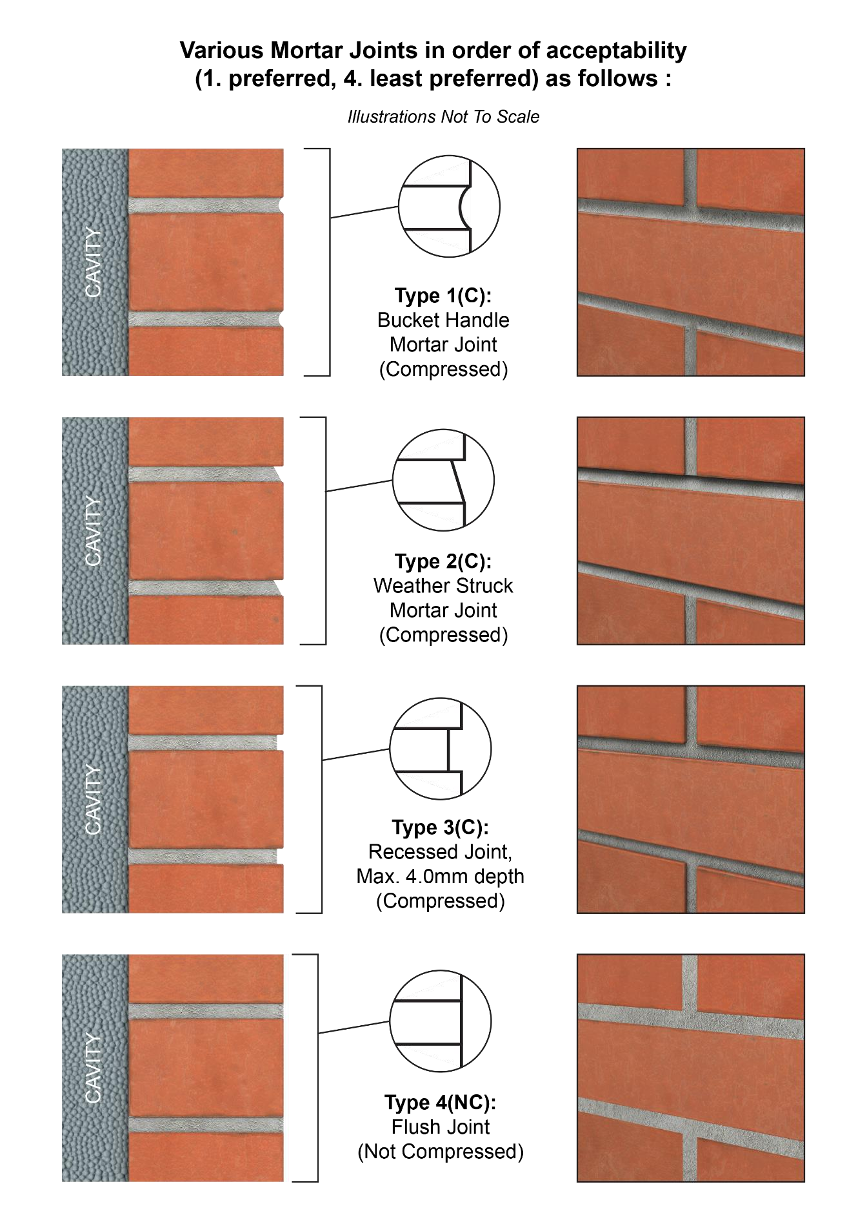

Figure 1 - Brick Mortar Joint Profiles (new build only)

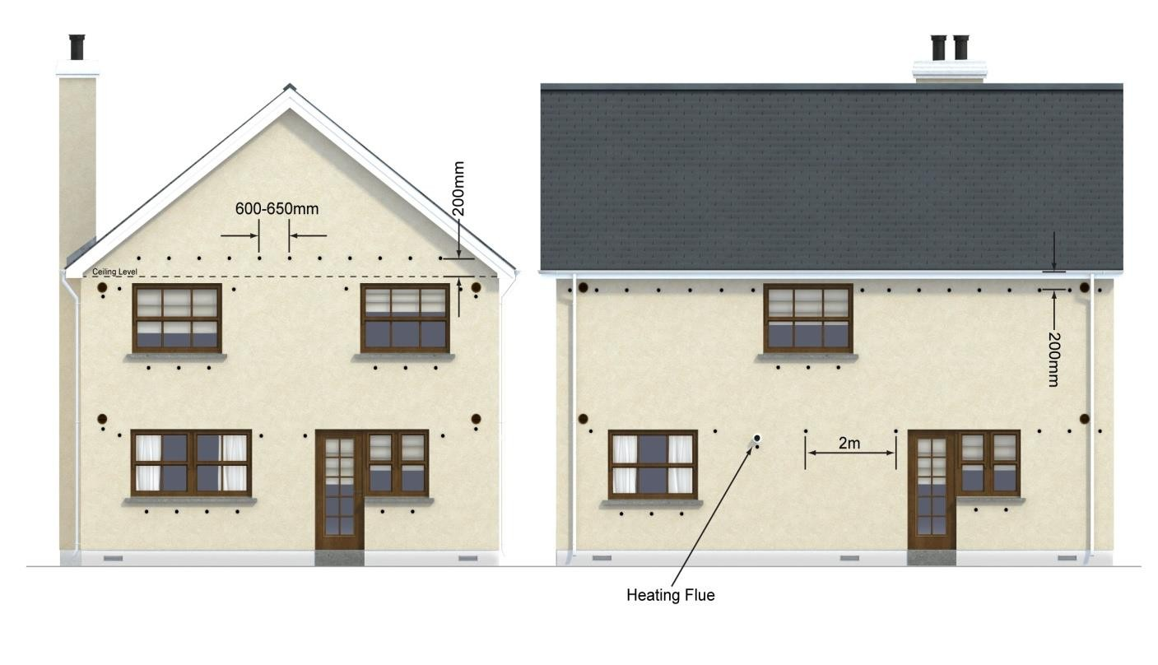
Two-story drill pattern

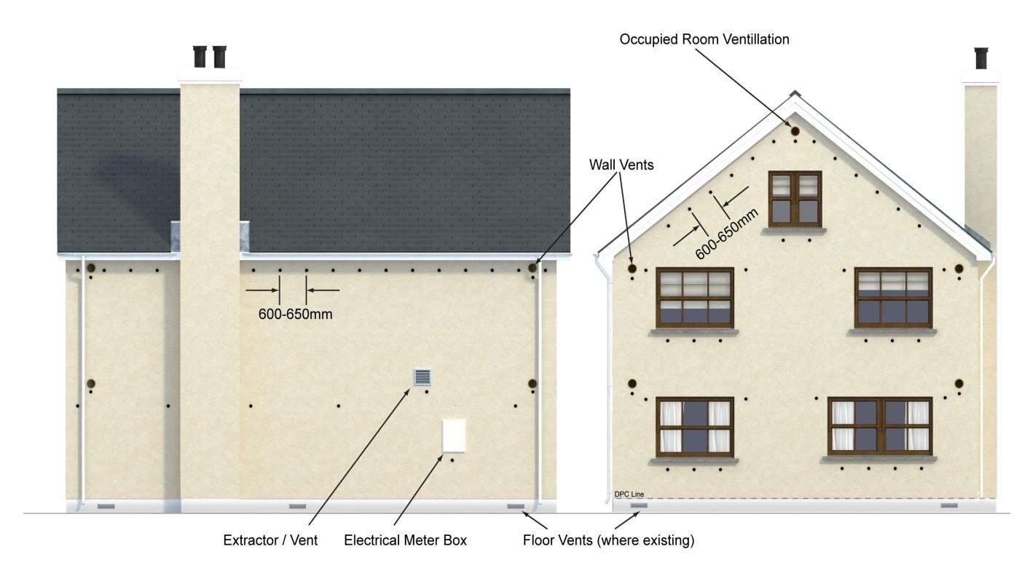
Figure 2 - Typical KOREFILL Hole Drilling Pattern in a Detached Dwelling
Two-story with room in roof drill pattern

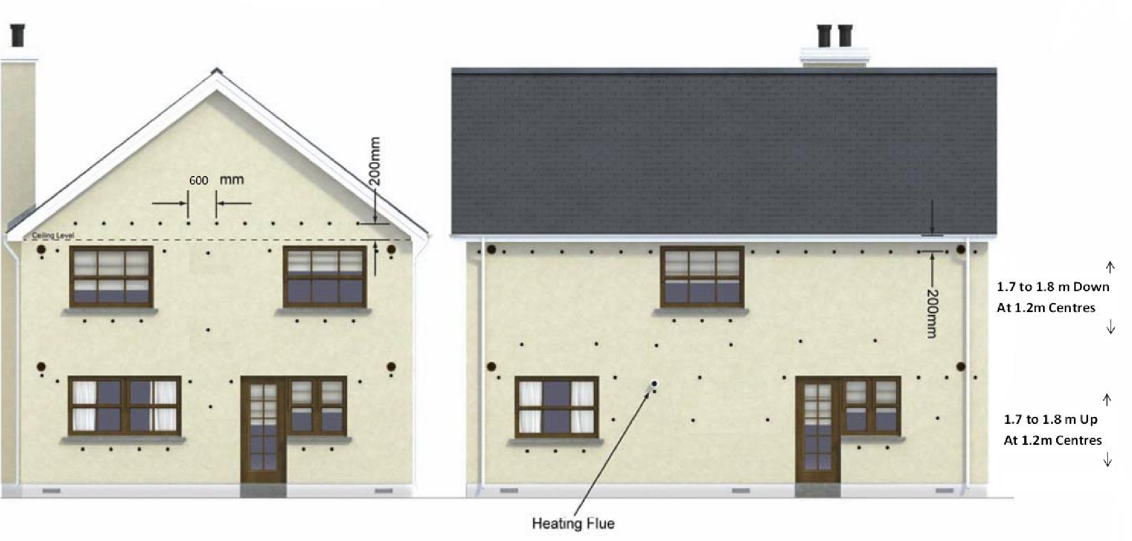

Two-story drill pattern

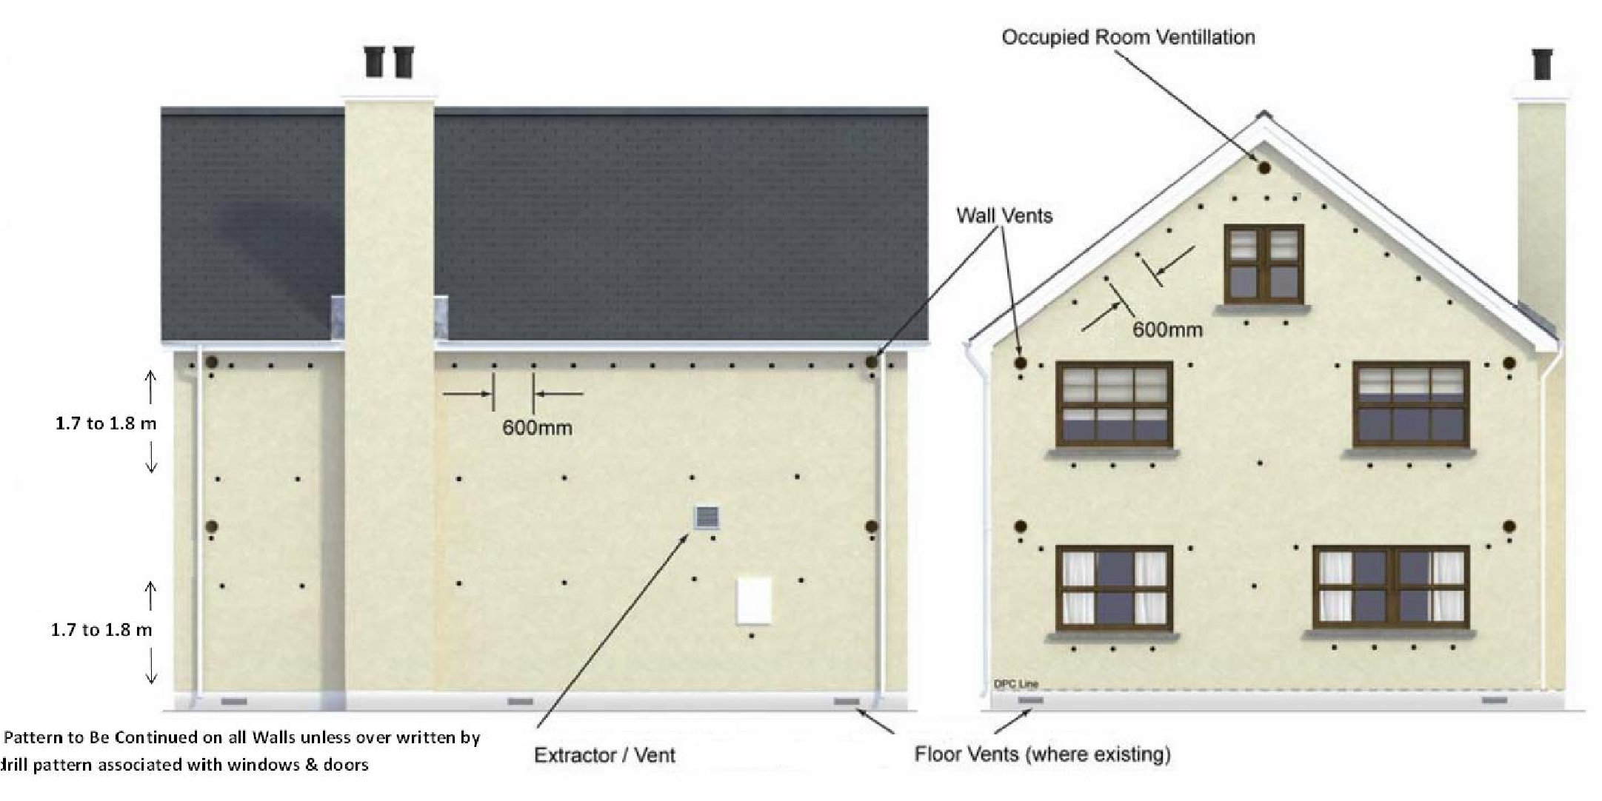
Two-story with room in roof drill pattern
Figure 3 - Typical KOREFILL Hole Drilling Pattern in a Detached Dwelling for Residual Fill Application - New and existing buildings with existing partial fill insulation in cavity.

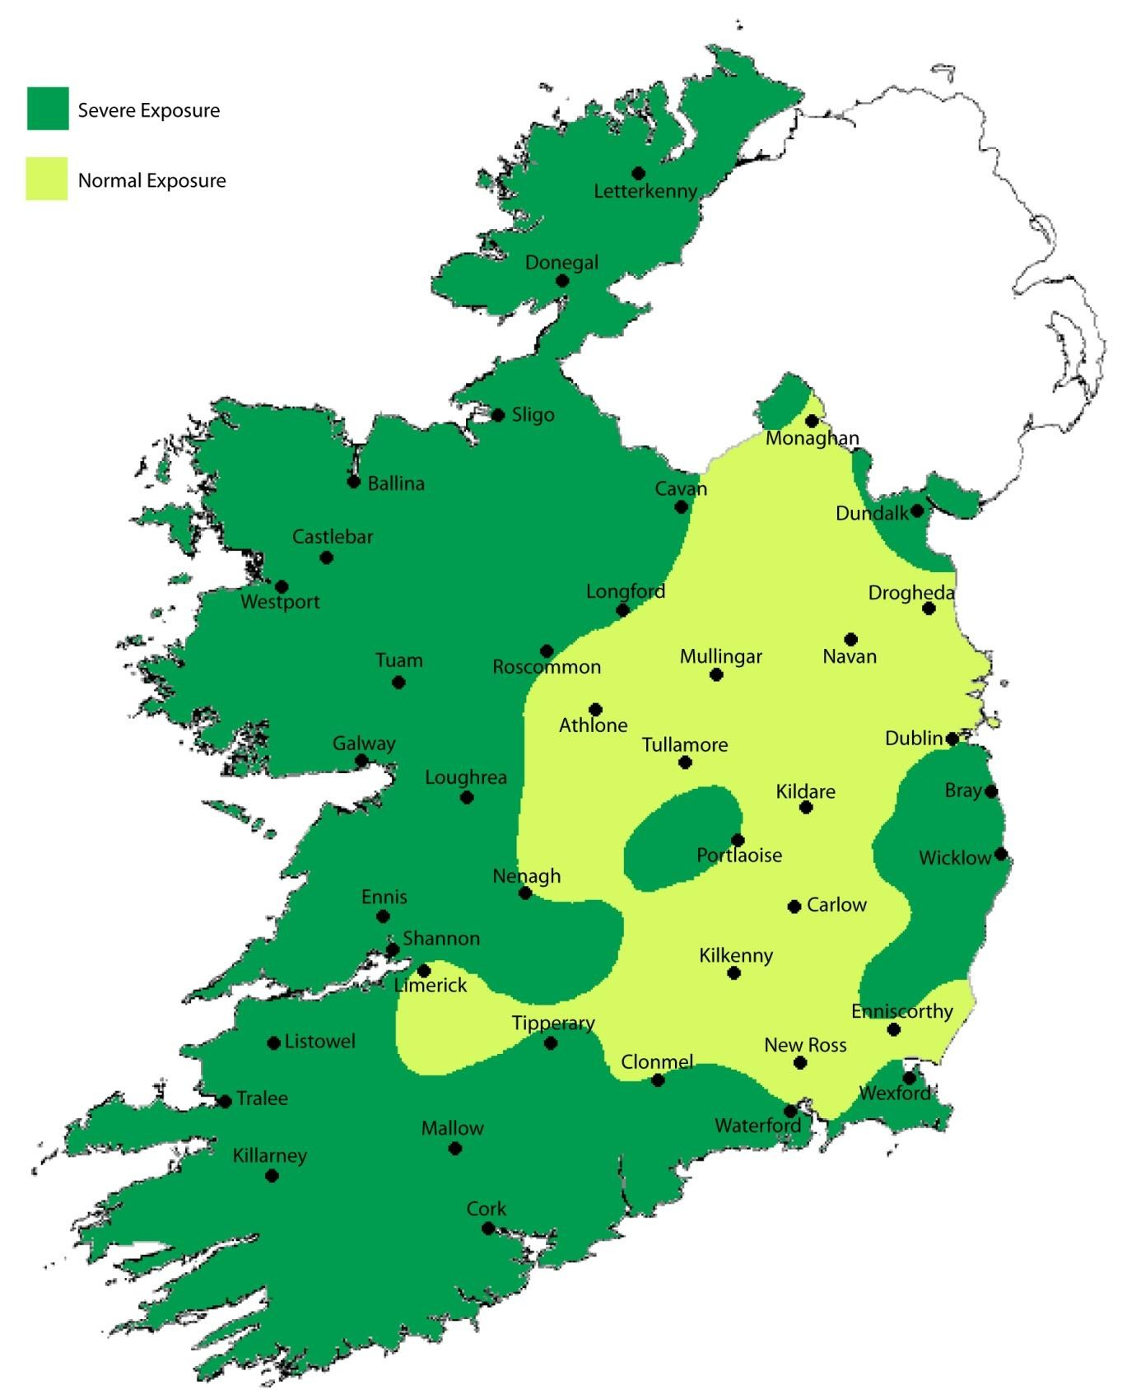

Figure 4 - Driving Rain Map (Indicative only – Not to scale)

4.1 BEHAVIOUR IN FIRE
4.1.1 Although the KOREFILL Original and Diamond Cavity Wall Insulation products are considered combustible, the system will meet the relevant requirements of TGD Part B3 & B8 when used in accordance with this certificate. The directions contained in this Certificate relating to the sealing of an uncapped cavity and removing insulant present in the loft space after installation must be carefully followed

All beads approved in this certificate contain a uniformly distributed polymeric flame retardant. The adhesives used a part of the system as describe in this certificate are water based and are not combustible.

When using this product, the requirements of the Building Regulations 1997 to 2019 relating to fire spread in cavity walls can be met in most purpose groups without the need for cavity barriers provided the walls are constructed in accordance with the following provisions of the TGD to Part B, including Diagram 17:

- The wall must consist of masonry or concrete inner and outer leaves, each at least 75 mm thick.

- The cavity must be closed at the top of walls and any other opening.

- In addition to the product, only the following combustible materials shall be placed in, or exposed to, the cavity:
  - timber lintel, window or door frame, or end
of timber joist
  - pipe, conduit
  - dpc flashing closer or wall tie
  - domestic meter cupboard, provided that:
  - there are not more than two cupboards to a dwelling.
  - the opening in the outer leaf is not more than 800 mm by 500 mm for each cupboard, and
  - the inner leaf is not penetrated except by a fire-stopped sleeve not more than 80 mm by 80 mm.
  - thermal insulating material
  - in respect of purpose groups 3 – 8 the cavities are sub-divided so that the distance between cavity barriers does not exceed the dimensions given in sub-section 3.3 of the TGD to Part B.

    - For buildings constructed of masonry or concrete cavity walls (as detailed in this certificate), in accordance with the Building Regulations 1997 to 2019 the product may be used in buildings of every purpose group.

    - Protection of Buildings Combustible cavity wall insulation material should be separated from the flue in a brick or blockwork chimney and from any heating appliance by solid non-combustible material not less than 200mm thick.

Alternatively, combustible material should be separated by 40mm from the outer surface of a masonry chimney.

Where a flue pipe from a heating system passes horizontally through a wall which is to be insulated with KOREFILL Original or Diamond Cavity Wall Insulation, the flue pipe shall be separated from the cavity insulation by non-combustible material in accordance with the TGD to Part J to the Irish Building Regulations.

Particular details are given in Diagrams 2 – 8 of the TGD to Part J of the Building Regulations 1997 to 2019 regarding separation from any flue pipe or opening to a heating appliance.

For factory made insulated chimneys, separation between this product and the external surface of the chimney shall be determined in accordance with Clause 2.17, of Part J of the Building Regulations 1997 to 2019.

4.2 LIQUID WATER PENETRATION
Test data obtained by NSAI Agrément confirms that a masonry cavity wall built to determine the effects of water resistance incorporating the KOREFILL Cavity Wall Insulation System did not transmit water to the inner leaf.

The KOREFILL Cavity Wall Insulation System, when used in accordance with this Certificate, presents no significant risk of water penetration.

4.3 CONDENSATION RISK
The KOREFILL Cavity Wall Insulation System is not a water vapour barrier and offers no resistance to vapourised moisture.

4.3.1 Internal Surface Condensation When improving the thermal performance of the external envelope of a building through the use of Cavity Wall Insulation, designers need to consider the impact of these improvements on other untouched elements of the building. As referenced in Clause 4.5 of this Certificate, thermally bridged sections of the envelope such as window jambs, sills, heads, internal wall and floor junctions and eaves will experience a lower level of increased thermal performance.

The ability to improve these junctions can be limited due to physical restrictions on site. As a result, best practice should be adopted in order to limit the risk of internal surface condensation which can result in dampness and mould growth.
Reference should be made to SR 54^{[2]} as required.

When site limiting factors give rise to substandard levels of insulation at bridged junctions, guidance should be sought from the Certificate holder as to acceptable minimum requirements.

4.3.2 Interstitial Condensation When a potential interstitial condensation risk is identified at design stage, a condensation risk analysis must be carried out. A transient hygrothermal (condensation) risk analysis in accordance with I.S. EN 15026 ^{[7]} can be used to predict one dimensional transient heat and moisture transfer in multi-layer building envelope components subjected to non-steady climate conditions on either side.

When a problem is identified, the design shall be modified as appropriate to reduce the risk of interstitial condensation to acceptable levels.

Alternatively, a steady state condensation risk analysis to I.S EN ISO 13788^{[6]}, must be performed at a minimum.

Further guidance may be obtained from BS5250^{[1]}.

4.4 THERMAL INSULATION
The thermal conductivity (_{90/90}) of the KOREFILL Cavity Wall Insulation system has been measured at 0.035 W/(mK) for the KOREFILL Original beads and 0.033 W/(mK) for the KOREFILL Diamond. These values are based on bead densities of 12 kg/m³.

The required maximum U-values for external walls can be obtained in typical cavity wall constructions as indicated in Table 1.

The U value of a completed wall will depend on the selected insulation thickness, the insulating value of the substrate masonry and its internal finish. Calculations of thermal transmittance (U value), including corrections for wall ties if required, should be carried out in accordance with I.S. EN ISO 6946^{[9]} and BRE report (BR 443)^{[10]} Conventions for U-value calculations using a thermal conductivity of 50 W/m.K for mild steel wall ties wall ties and 17W/m.k for Stainless steel wall ties.

Where the calculated wall U-value does not meet the relevant requirement of the Building Regulations, additional energy improvement measures will be required to meet the backstop elemental U-values outlined in TGD to Part L of the Building Regulations.

4.5 LIMITING THERMAL BRIDGING
The linear thermal transmittance “Ψ” (Psi) describes the additional heat loss associated with junctions and around openings.

The requirements of TGD to Part L, Appendix D applies to all thermal bridges. Reference should be made to the Acceptable Construction Details (ACD’s) or consult with an NSAI registered Thermal Modeller.

It is recommended that continuity of the blown bead insulation be maintained to limit the instances of thermal bridging, to maintain internal surface temperatures at sufficiently high levels in order to minimise the risk of surface condensation and mould growth. Reference should be made to SR54^{[2]} in this regard. The site surveyor shall assess the construction and recommend additional measures if required.

4.6 DURABILITY
The KOREFILL Cavity Wall Insulation System is rotproof, water repellent and durable. When installed in accordance with this certificate, it is sufficiently stable to prevent settlement and will remain effective as an insulant for the life of the building.

Should it ever become necessary, for whatever reason, to remove the material from the cavity void, KOREFILL Cavity Wall Insulation can be evacuated from the cavity void. The advice of the Certificate Holder should be sought in all such instances.

4.7 MAINTENANCE
As the product is confined within the wall cavity and has suitable durability (See Clause 4.6 of this certificate), maintenance is not required.

4.8 TESTS AND ASSESSMENTS WERE CARRIED OUT TO DETERMINE THE FOLLOWING
- Efficiency of fill in clear and residual cavities using the specified equipment and drilling pattern.
- Density of factory manufacture bead.
- Water resistance of filled cavity wall.
- Thermal conductivity.

4.9 OTHER INVESTIGATIONS
- Existing data on product properties in relation to fire, toxicity, environmental impact and the effect on structural stability and durability were assessed. The absence of chloro-fluorocarbon gases ‘CFCs’ has been established.
- The manufacturing process was examined including the methods adopted for quality control, and details were obtained of the quality and composition of the materials used.
- Site visits were conducted to assess the practicability of installation.
- Driving rain resistance was assessed.
- A condensation risk analysis of the system was performed.
- Suitability for use of the product to fill residual cavities in partial fill installations. See certificate for details and restrictions.

Table 1 - External Masonry Walls – Estimated U Values W/(m²K)
Cavity fill | ●  W/(m.k) | Rendered Cavity Wall - Type I
KOREFILL Original | 0.035 | Unventilated Cavity width (mm)
 |  | 50 | 60 | 70 | 80 | 90 | 100 | 110 | 120 | 130 | 140
 |  | U-value (W/m²K)
 |  | 0.55 | 0.48 | 0.42 | 0.37 | 0.34 | 0.31 | 0.28 | 0.26 | 0.24 | 0.23
 |  | Unventilated Cavity width (mm)
 |  | 150 | 160 | 170 | 180 | 190 | 200 | 210 | 220 | 225
 |  | U-value (W/m²K)
 |  | 0.21 | 0.20 | 0.19 | 0.18 | 0.17 | 0.16 | 0.16 | 0.15 | 0.15
KOREFILL Diamond | 0.033 | Unventilated Cavity width (mm)
 |  | 50 | 60 | 70 | 80 | 90 | 100 | 110 | 120 | 130 | 140
 |  | U-value (W/m²K)
 |  | 0.53 | 0.45 | 0.40 | 0.36 | 0.32 | 0.29 | 0.27 | 0.25 | 0.23 | 0.22
 |  | Unventilated Cavity width (mm)
 |  | 150 | 160 | 170 | 180 | 190 | 200 | 210 | 220 | 225
 |  | U-value (W/m²K)
 |  | 0.20 | 0.19 | 0.18 | 0.17 | 0.16 | 0.16 | 0.15 | 0.14 | 0.14
 |  | Brick Cavity Wall - Type II
KOREFILL Original | 0.035 | Unventilated Cavity width (mm)
 |  | 50 | 60 | 70 | 80 | 90 | 100 | 110 | 120 | 130 | 140
 |  | U-value (W/m²K)
 |  | 0.54 | 0.47 | 0.41 | 0.37 | 0.33 | 0.30 | 0.28 | 0.26 | 0.24 | 0.23
 |  | Unventilated Cavity width (mm)
 |  | 150 | 160 | 170 | 180 | 190 | 200 | 210 | 220 | 225
 |  | U-value (W/m²K)
 |  | 0.21 | 0.20 | 0.19 | 0.18 | 0.17 | 0.16 | 0.16 | 0.15 | 0.15
KOREFILL Diamond | 0.033 | Unventilated Cavity width (mm)
 |  | 50 | 60 | 70 | 80 | 90 | 100 | 110 | 120 | 130 | 140
 |  | U-value (W/m²K)
 |  | 0.51 | 0.45 | 0.39 | 0.35 | 0.32 | 0.29 | 0.27 | 0.25 | 0.23 | 0.21
 |  | Unventilated Cavity width (mm)
 |  | 150 | 160 | 170 | 180 | 190 | 200 | 210 | 220 | 225
 |  | U-value (W/m²K)
 |  | 0.20 | 0.19 | 0.18 | 0.17 | 0.16 | 0.15 | 0.15 | 0.14 | 014
Wall Type I - 19mm external render on 100/clear cavity of width shown/100 block cavity wall (100mm clear cavity) with 12.5mm internal plasterboard
Wall Type II - 102.5mm external brick/clear cavity of width shown/100 block inner leaf with 12.5mm internal plasterboard.
(Internal plasterboard – dabbed or mechanically fixed without air gap or insulation).
The U-values above includes allowances for stainless steel wall ties (with a thermal conductivity of 17 W/mk) of 3.3mm Ø @ 2.5 per m² for cavity’s up to 75mm wide; 3.3mm Ø @ 3 per m² for cavity’s 76-100mm wide; 3.3mm Ø @ 4.9 per m² for cavity’s 101-150mm wide and 5.5mm Ø @ 2.5 per m² for cavity’s 151-225mm wide. All wall ties fully penetrate the insulation layer.

U-value calculations for residual filling of partial fill cavity walls are dependent on the thickness and type of existing insulation and the width of the residual cavity. Individual U-value calculations are required in all such instances with details of calculations (including existing insulation type and thickness) to be recorded on the Site Survey Record Sheet. The KOREFILL Diamond bead has not be assessed or approved for use in residual fill applications when the remaining cavity width to be filled is less than 50mm. See Clause 2.4.4.2 of this Certificate for details.

The above values represent the most optimistic values achievable for the wall constructions shown filled with the KOREFILL cavity wall insulation systems. The thermal conductivity and consequent U values quoted will be affected by adhesive use and the installed density of the product.
Excessive use of adhesive and installed densities of less than 12kg/m³ are unlikely to meet the above quoted U values.
Additional measures can be taken to improve the U-value of the wall including use of thermally efficient walls ties and the use of additional thermal insulation measures such as internal dry lining or external insulation. A condensation rise analysis should be performed when additional insulation measures are taken.

The construction of walls with cavities in excess of 110mm wide requires adjustments to lintels, wall ties, cavity barriers, etc. It is therefore necessary that cavity walls are adequately designed in respect of structural stability and fire safety in accordance with Parts A and B of the Building Regulations. For Table 1, it is assumed that cavity walls containing full-fill bonded bead will be constructed in accordance with the requirements of the Building Regulations, 1997 to 2019. This falls under the responsibility of the commissioning party.

5.0 CONDITIONS OF CERTIFICATION
5.1 National Standards Authority of Ireland ("NSAI") following consultation with NSAI Agrément has assessed the performance and method of installation of the product/process and the quality of the materials used in its manufacture and certifies the product/process to be fit for the use for which it is certified provided that it is manufactured, installed, used and maintained in accordance with the descriptions and specifications set out in this Certificate and in accordance with the manufacturer's instructions and usual trade practice. This Certificate shall remain valid for five years from date of last revision date so long as:

- the specification of the product is unchanged.

- the Building Regulations 1997 to 2019 and any other regulation or standard applicable to the product/process, its use or installation remains unchanged.

- the product continues to be assessed for the quality of its manufacture and marking by NSAI.

- no new information becomes available which in the opinion of the NSAI, would preclude the granting of the Certificate.

- the product or process continues to be manufactured, installed, used and maintained in accordance with the description, specifications and safety recommendations set out in this certificate.

- the registration and/or surveillance fees due to NSAI Agrément are paid.

  - The NSAI Agrément mark and certification number may only be used on or in relation to product/processes in respect of which a valid Certificate exists. If the Certificate becomes invalid the Certificate holder must not use the NSAI Agrément mark and certification number and must remove them from the products already marked.

  - In granting Certification, the NSAI makes
no representation as to;

- the absence or presence of patent rights
subsisting in the product/process; or

- the legal right of the Certificate holder to market, install or maintain the product/process; or

- whether individual products have been manufactured or installed by the Certificate holder in accordance with the descriptions and specifications set out in this Certificate.

  - This Certificate does not comprise installation instructions and does not replace the manufacturer's directions or any professional or trade advice relating to use and installation which may be appropriate.

  - Any recommendations contained in this
Certificate relating to the safe use of the certified product/process are preconditions to the validity of the Certificate. However, the NSAI does not certify that the manufacture or installation of the certified product or process in accordance with the descriptions and specifications set out in this Certificate will satisfy the requirements of the Safety, Health and Welfare at Work Act 2005, or of any other current or future common law duty of care owed by the manufacturer or by the Certificate holder.

  - The NSAI is not responsible to any person or body for loss or damage including personal injury arising as a direct or indirect result of the use of this product or process.

  - Where reference is made in this Certificate to any Act of the Oireachtas, Regulation made thereunder, Statutory Instrument, Code of Practice, National Standards, manufacturer's instructions, or similar publication, it shall be construed as reference to such publication in the form in which it is in force at the date of this Certification.

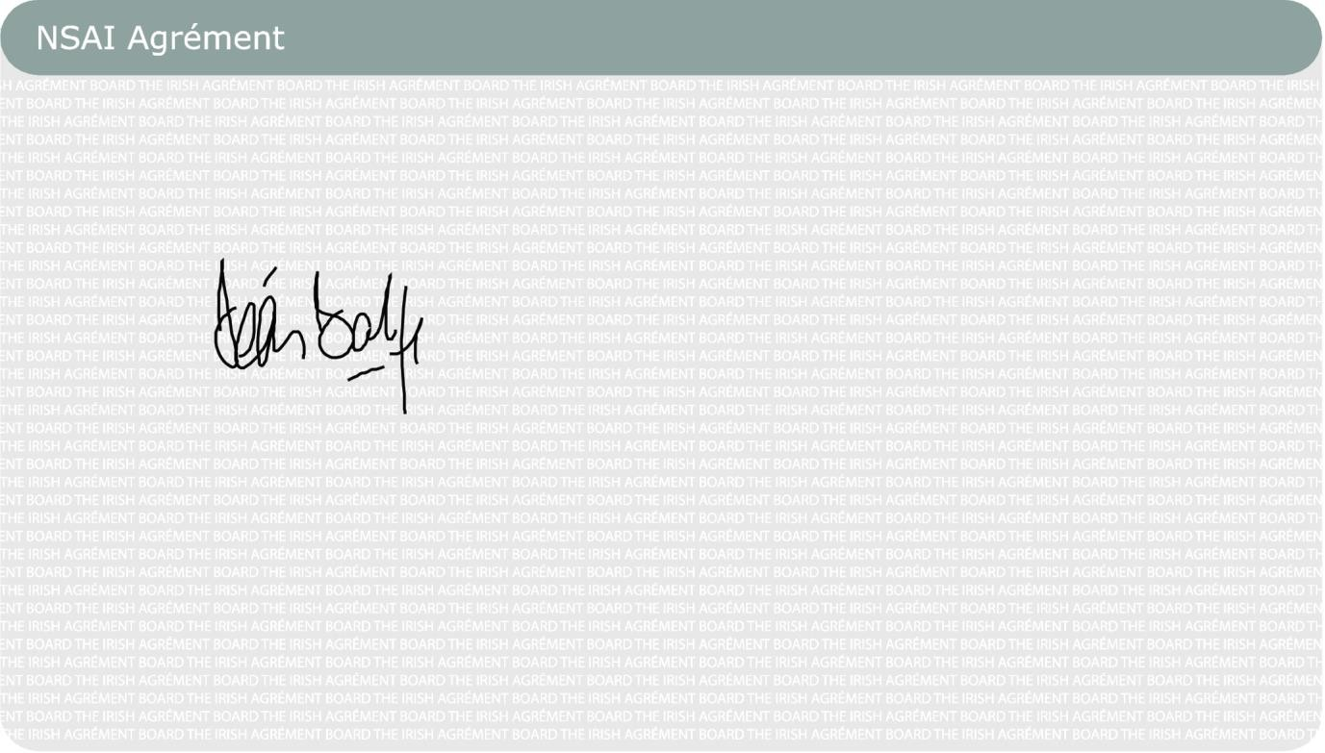
This Certificate No.
07
/0293
is accordingly granted by the NSAI
Airpacks

L
td.

on behalf of
NSAI Agrément.

Date of Issue:
November
200
7

Signed

Seán Balfe

Director of NSAI Agrément

Readers may check that the status of this Certificate has not changed by conta
cting NSAI
Agr
ément
, NSAI, 1 Swift Square, Northwood, Santry, Dublin 9, Ireland. Telephone: (01) 807 3800.
Fax: (01) 807 3842.
www.nsai.i
e

Revisions:

February 2014:
To add additional information and other general changes.

September 2015:
The inclusion of an additional bead and other general notes.

July 2020:

Clarification on Mortar joints, inclusion of wider cavity thermal values and general

layout of Certificate.

22
nd

December 2020:
General revis
ions.

Bibliography

- BS 5250:2011+A1:2016, Code of practice for the control of condensation in buildings.
- SR54: 2014 & A1:2019, Code of Practice for the energy efficient retrofit of dwellings.
- BS 8208: Part 1:1985, Guide for the assessment of suitability of external cavity walls, for filling with thermal insulants – Existing traditional cavity construction.
- BS 8104:1992, Code of practice for assessing exposure of walls to wind driven rain.
- I.S 10101: 2020: National Rules for Electrical Installations.
- I.S EN ISO 13788:2012: Hygrothermal performance of building components and building elements - Internal surface temperature to avoid critical surface humidity and interstitial condensation – Calculation Methods.
- I.S. EN 15026: 2007, Hygrothermal performance of building components and building elements - Assessment of moisture transfer by numerical simulation.
- DoHPLG Acceptable Construction Details (ACD’s): 2011.
- I.S. EN ISO 6946: 2017: Building Components and Building Elements - Thermal Resistance and Thermal Transmittance - Calculation Method.
- BRE report BR443 (2019): Conventions for U-value Calculations.
- I.S EN 13163: 2012: Thermal insulation products for buildings - Factory made expanded polystyrene (EPS) products – Specification.
- I.S EN 13501-1: 2018: Fire classification of construction products and building elements- Part 1: Classification using data from reaction to fire tests.
- I.S. EN 13172: 2012: Thermal insulation products - Evaluation of conformity.

